YUNIQ

Digital Marketing Plan
Three-Month Client Acquisition Campaign | October-December 2026
CAMPAIGN IDEA
Beyond One Community: a practical bilingual visibility campaign that helps Calgary small businesses turn useful social content into qualified consultation leads.

Prepared by | Program | Date
Yunjing (Hannah) Zhang | CIWA Digital Marketing | September 1, 2026

Prepared for academic purposes. All projections are campaign targets, not historical results.

EXECUTIVE OVERVIEW

Plan at a Glance
Yuniq is a Calgary-based creator-commerce and digital marketing brand designed to help local small businesses reach customers beyond one familiar community. Its advantage is not simply translation. Yuniq combines bilingual cultural insight, short-form storytelling, creator-style production, and practical measurement so small business owners can communicate clearly across English-language and Chinese-language digital spaces.
PRIMARY SMART OBJECTIVE
Between October 1 and December 31, 2026, the Beyond One Community campaign will generate 15 qualified consultation leads from Calgary-area small businesses and convert at least 3 of those leads into paid pilot clients through a bilingual lead magnet, short-form content, email nurturing, and a free 20-minute visibility check.

Campaign | Audience | Core offer | Primary CTA
Beyond One Community | Time-poor Calgary small business owners, especially immigrant-led food, retail and service brands | A practical path from unclear content to measurable local visibility | Book a free 20-minute Visibility Check

Contents
Section | What it covers
1. Introduction and Objectives | Company, challenge, goals and SMART targets
2. Competitive Analysis | URBA and Full Blast Creative; market gap for Yuniq
3. Customer Persona | David Wong, needs, barriers, journey and Yuniq USP
4. Media Channels | Owned, shared, paid and earned channel roles
5. Campaign Overview | Acquisition strategy, message, offer, CTA and funnel
6. Creative and Execution | Tactics, mockups, schedule, budget and measurement
7. Conclusion | Why the plan can achieve its objectives

STRATEGY

1. Introduction and Digital Marketing Objectives

Company introduction
Yuniq is an emerging Calgary digital marketing and creator-commerce brand. It supports local restaurants, retailers and service businesses that have a strong product but limited time, confidence or in-house resources for digital marketing. The brand promise is “Grow your brand beyond one community.” Yuniq helps clients communicate with both mainstream Calgary audiences and Chinese-speaking communities through short-form video, social media storytelling, content planning, local SEO thinking and creator partnerships.
The immediate business need is predictable client acquisition. Awareness alone is not enough for a new service brand: the campaign must create a clear path from discovering Yuniq, to receiving useful value, to booking a conversation, and finally to testing a paid service.

Overall marketing goals
- Build trust by demonstrating useful, culturally aware marketing expertise rather than relying on hard-sell advertising.
- Create an owned audience through email so Yuniq is not dependent only on social algorithms.
- Generate qualified conversations with local decision-makers who have a real visibility problem and an achievable marketing need.
- Establish a repeatable campaign system that can be improved with UTM, email and consultation data.

SMART objectives for October-December 2026
Objective | Measure and target | Why it is SMART
Primary: qualified leads | Generate 15 Calgary small-business consultation leads and convert at least 3 into paid pilot clients by Dec. 31. | Specific audience and action; measurable in CRM; realistic for a focused founder-led campaign; relevant to revenue; time-bound.
Owned audience | Gain 100 new opt-in email subscribers through the Calgary Local Visibility Scorecard by Dec. 31. | Creates a measurable first-party audience that can be nurtured beyond the campaign.
Traffic and awareness | Generate 300 campaign landing-page visits and at least 20,000 Calgary-relevant social impressions during the period. | Provides enough top-of-funnel volume to test message, channel and conversion assumptions.

MARKET CONTEXT

2. Competitive Analysis
The Calgary market includes large full-service agencies, specialist social media teams, independent creators and low-cost content suppliers. Yuniq does not need to outscale established agencies. It needs to own a narrower position: practical bilingual growth support for small businesses that want local reach without losing cultural authenticity.

Competitor 1: URBA
Positioning and UVP | Marketing strategies | Implication for Yuniq
A city-focused media network that connects brands with large, engaged local audiences and promotes what is happening across major Canadian cities. | Publishes high-volume local discovery content about events, restaurants and city culture; sells brand features and network reach; uses social proof through visible audience and performance metrics; supports local discovery and event promotion. | URBA is powerful for broad local exposure. Yuniq should not compete on audience scale. It should compete on hands-on bilingual strategy, founder access, cultural adaptation and a clear lead-to-conversion process for smaller clients.

Source: URBA official website

Competitor 2: Full Blast Creative
Positioning and UVP | Marketing strategies | Implication for Yuniq
A full-service, results-oriented Calgary marketing agency offering strategy, web, social media, advertising, SEO/PPC, branding and production. | Uses an integrated service menu; combines organic and paid social; offers community management, influencer marketing and crisis support; demonstrates expertise through service pages, case work and educational content; emphasizes agreed business outcomes. | Full-service depth can appeal to larger or more complex accounts. Yuniq can remain easier to understand and access: one focused visibility problem, one founder-led point of contact, small pilot packages and bilingual creator-style execution.

Sources: Full Blast Creative and social media services

Competitive gap and response
Market expectation | How Yuniq responds
Local relevance | Calgary-specific examples, local keywords, local events and community partnerships.
Professional content | Founder-led photography, short-form video, bilingual captions and platform-native editing.
Measurable outcomes | UTM links, landing-page conversion, email opt-ins, consultations and client conversions.
Lower perceived risk | A free diagnostic followed by a defined, affordable pilot instead of an open-ended retainer.
Cross-cultural reach | Message adaptation for English and Chinese audiences, not word-for-word translation.

AUDIENCE

3. Customer Persona and Unique Selling Proposition
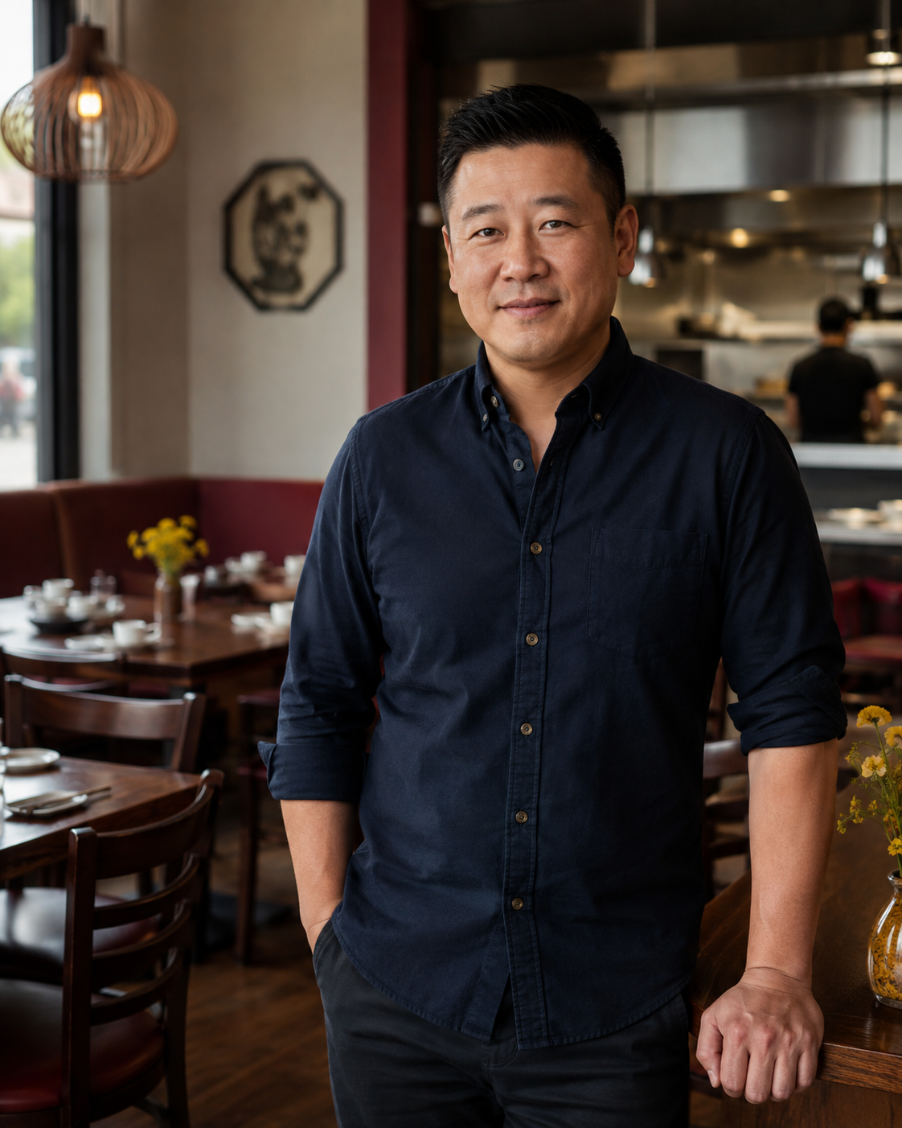  Fictional persona image | DAVID WONG  42 | Calgary | Independent restaurant owner  GOAL  Reach more English-speaking customers while keeping the restaurant’s cultural identity.  PAIN POINTS  Very limited time; uncertain what to post; English copy takes too long; influencer costs and results feel unclear.  MOTIVATION  More weekday traffic, stronger local recognition and marketing that can be connected to sales.  OBJECTIONS  “Will this bring customers?” “Can I afford it?” “Will the content still feel like us?”  DIGITAL BEHAVIOUR  Uses Instagram, Facebook, Google and WeChat/Rednote; checks competitors; prefers practical examples and referrals.  DECISION TRIGGER  A low-risk diagnostic, visible proof of understanding, transparent scope and a simple next step.

Unique selling proposition
YUNIQ USP
Yuniq helps Calgary small businesses grow beyond one community by combining bilingual cultural insight, creator-style content and practical performance tracking in one accessible, founder-led service.

Unlike broad agencies, Yuniq begins with the communication gap experienced by immigrant-led small businesses. Unlike a single influencer post, it builds an owned funnel and a repeatable content system. The value is not “more posts”; it is clearer content, wider local relevance and a measurable next step.

Customer journey
Stage | Customer thought | Yuniq response | Success signal
Awareness | “My content is not reaching enough new people.” | Relatable Reels, local SEO tips and cross-cultural examples. | Video views, saves, profile visits
Consideration | “Does Yuniq understand my business?” | Scorecard, case examples, checklist and founder story. | Landing visits, opt-ins, replies
Decision | “Is this worth the risk?” | Free Visibility Check and defined paid pilot. | Bookings, qualified leads, proposals
Early loyalty | “Can this keep working?” | Clear report, next-step plan and referral request. | Pilot conversion, testimonial, referral

DISTRIBUTION

4. Media Channels
Channel selection follows the persona and the acquisition objective. David has little time, so Yuniq must appear where he already looks for ideas while moving him toward owned channels where the relationship can continue. The mix emphasizes organic founder-led content, supported by a small paid retargeting budget.
Channel | Category | Role in campaign | Reason for selection
Website landing page + blog | Owned | Explain the offer, collect opt-ins and book consultations. | Conversion hub; supports search and UTM measurement.
Email / Mailchimp | Owned | Deliver scorecard and nurture subscribers through 4 emails. | Low-cost, direct and not controlled by an algorithm.
Instagram | Shared | Reels, carousels, Stories and local collaboration posts. | Strong visual fit for food, retail, service and creator content.
TikTok | Shared | Fast educational and behind-the-scenes videos. | Efficient discovery and authentic short-form storytelling.
Rednote | Shared | Chinese-language cultural adaptation and local discovery content. | Direct relevance to Chinese-speaking residents and immigrant-led businesses.
LinkedIn | Shared | Founder expertise, case thinking and professional trust. | Reaches owners, managers and referral partners.
Meta retargeting | Paid | Retarget landing visitors and engaged users with the scorecard/consultation CTA. | Controls spend and prioritizes warm users instead of broad cold ads.
Partner/creator reshares | Earned | Community associations, local creators and past collaborators amplify selected posts. | Adds trust and extends reach without depending only on paid media.

Channel integration
Discover | Capture | Nurture | Convert
Reels, TikTok, Rednote, LinkedIn, partner reshares | Landing page + Calgary Local Visibility Scorecard | Four-email sequence + practical case content | Free 20-minute Visibility Check + paid pilot offer

Every campaign link will use a channel-specific UTM source and medium. This makes it possible to compare traffic, opt-ins and bookings by platform. A single consistent landing page reduces tracking gaps and makes the customer journey easier to understand.
ACQUISITION CAMPAIGN

5. Campaign Overview

Campaign objective and concept
The campaign objective is acquisition: turn relevant attention into identifiable prospects and then into qualified consultations. “Beyond One Community” dramatizes a familiar problem for immigrant-led businesses: customers inside one community may already understand the brand, while many nearby Calgary customers do not know why they should visit or buy.
CORE MESSAGE
Your business does not need to lose its identity to reach more people. It needs clearer, culturally aware content and one measurable next step.

Offer and calls to action
Level | Offer / CTA | Purpose
Low commitment | Save this post / follow for practical Calgary marketing ideas. | Build familiarity and create retargeting audiences.
Lead capture | Download the free Calgary Local Visibility Scorecard. | Exchange immediate value for permission to email.
Primary conversion | Book a free 20-minute Visibility Check. | Qualify the need and recommend the next best action.
Revenue | Start a 30-day bilingual visibility pilot. | Convert qualified prospects with a defined, lower-risk scope.

Campaign funnel and content pillars
Content pillar | Example | Funnel role
Visibility problems | “Three reasons Calgary customers scroll past a great restaurant.” | Awareness
Practical education | Hooks, local keywords, CTA fixes and UTM basics. | Awareness / consideration
Proof and process | Before-and-after content, campaign breakdowns and creator workflow. | Consideration
Cross-cultural insight | How to adapt a message across English and Chinese audiences. | Consideration / differentiation
Invitation | Scorecard, Visibility Check and 30-day pilot. | Conversion

Three-month sequence
Month | Focus | Key actions | Primary KPI
October | Problem awareness | Launch hero Reel, 2 educational Reels/week, 1 carousel/week, founder LinkedIn posts, scorecard landing page. | Reach, saves, landing visits
November | Trust and lead capture | Case-style content, collaborator reshares, scorecard promotion, email nurture, low-budget retargeting. | Opt-ins, cost per lead, replies
December | Consultation and pilot | FAQ/objection content, consultation CTA, limited pilot availability, personalized follow-up. | Bookings, qualified leads, paid pilots

TACTICS AND MOCKUPS

6. Creative and Execution

Creative direction
The creative system will feel human, useful and locally grounded. It uses real business environments, concise language, warm photography and Yuniq’s lemon-yellow brand colour, supported by white and dark navy for clarity and contrast. The tone avoids marketing jargon and hard-sell claims. English and Chinese versions will be adapted for platform context rather than translated word for word.
Creative rule | Application
Hook quickly | Show the business problem in the first 1-2 seconds or first carousel card.
One post, one job | Each asset has one main idea and one primary CTA.
Show people and process | Use owners, staff, customers, food, products and behind-the-scenes work.
Design for silent viewing | On-screen captions, high contrast and plain-language headlines.
Create once, adapt carefully | Use one insight across Reel, carousel, email and LinkedIn, with platform-native edits.

Mockup A: short-form awareness video
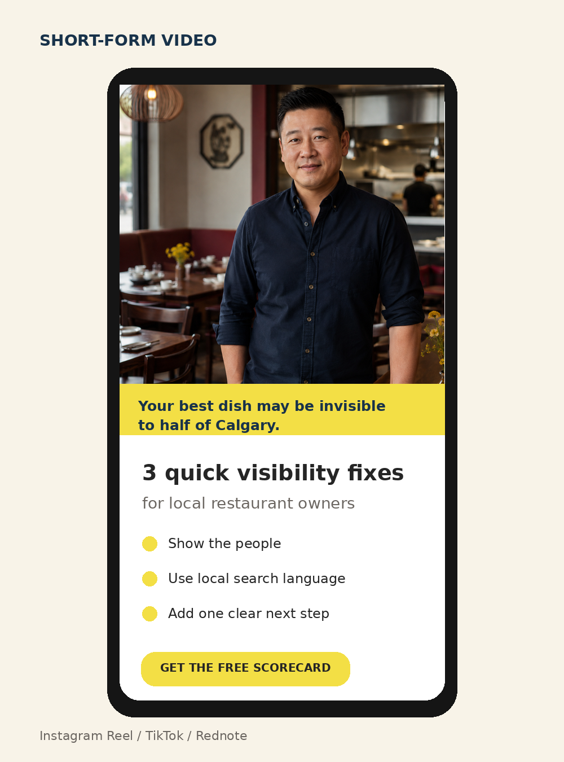
The opening names a recognizable visibility problem, gives three practical fixes, and directs interested owners to the free scorecard. The same concept can be adapted for Instagram Reels, TikTok and Rednote with platform-specific captions.

LEAD CAPTURE AND NURTURE

Creative Mockups
MOCKUP B / LANDING PAGE  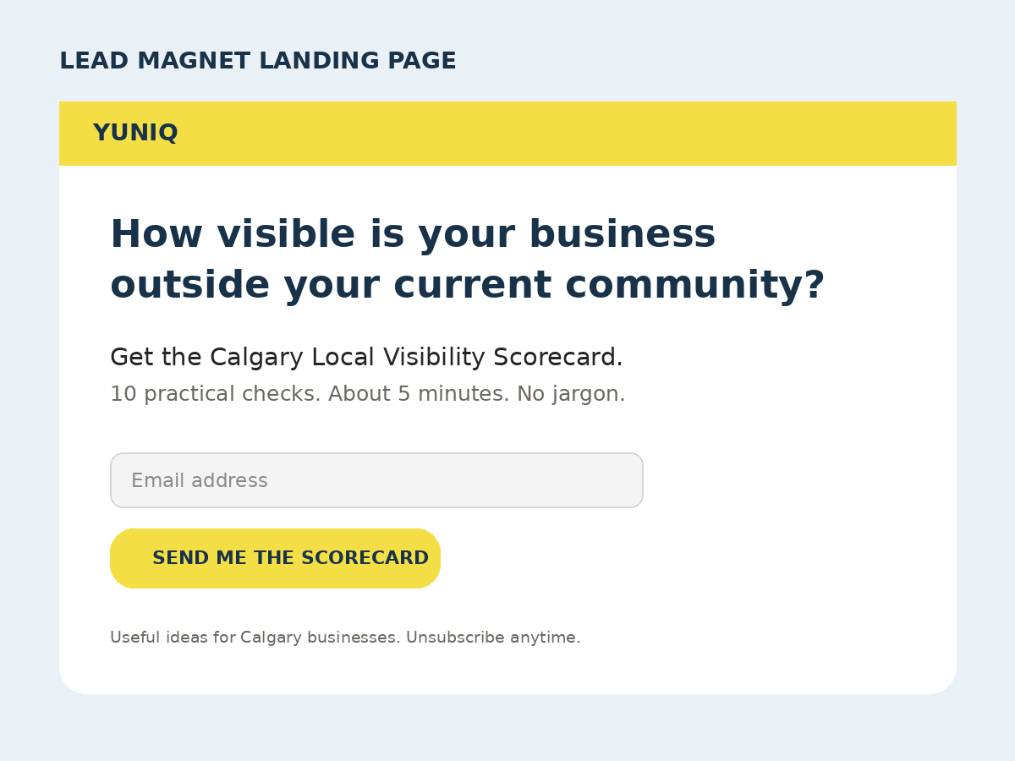  The lead magnet gives immediate value and collects permission to continue the relationship by email. | MOCKUP C / EMAIL    The nurture email offers one useful improvement, then invites a low-pressure Visibility Check.

Four-email nurture sequence
Email | Subject / purpose | CTA
1. Deliver | Here is your Calgary Visibility Scorecard — deliver the promised resource. | Use the scorecard
2. Quick win | The three-second clarity check — make the next post easier to understand. | Reply with a content question
3. Proof | One message, two communities — show how cultural adaptation changes execution. | View a campaign example
4. Invite | Want a second pair of eyes? — address time, budget and authenticity objections. | Book the Visibility Check

CAMPAIGN OPERATIONS

Execution Plan, Budget and Measurement

Publishing cadence
Tactic | Cadence | Three-month output
Short-form video | 2 per week | Approximately 24 videos adapted across selected platforms
Carousel / static education | 1 per week | Approximately 12 posts
Stories / informal updates | 3-4 days per week | Process clips, polls, FAQs and CTA reminders
LinkedIn founder content | 1 per week | 12 professional insight or case posts
Email nurture | Triggered sequence | 4 automated emails per new subscriber
Consultation follow-up | Within 24 hours | Personal recap and recommended paid pilot

Working budget (CAD)
Item | Budget | Reason
Meta retargeting | $450 | Warm-audience support; approximately $5/day during active periods.
Landing page/email/tools | $150 | Domain, email or design/tool allowance.
Production/transport/props | $200 | Local filming logistics and small production needs.
Contingency | $100 | Testing, replacement assets or small collaboration cost.
Total | $900 | A lean founder-led test before increasing spend.

Measurement framework
Funnel stage | KPI | Target | Tool / source
Awareness | Relevant social impressions | 20,000+ | Native platform insights
Interest | Landing-page visits | 300 | GA4 + UTM links
Lead capture | New email subscribers | 100 | Mailchimp + landing form
Intent | Qualified consultation leads | 15 | Booking form + CRM sheet
Revenue | Paid pilot clients | 3 | Proposal / invoice record
Efficiency | Lead-to-consultation conversion | 15% target | Leads divided by consultations

Performance will be reviewed weekly. Creative hooks, landing-page conversion and channel-level lead quality will be compared. Major changes will be made only after enough data has accumulated to avoid reacting to one post. At the end of December, Yuniq will document what produced qualified conversations and use those findings to plan the next campaign.
RECOMMENDATION

7. Conclusion
The Beyond One Community campaign gives Yuniq a focused and achievable route from awareness to revenue. It is designed around a specific Calgary small-business persona, a clear acquisition objective and a practical channel mix that respects a founder-led budget. Social platforms create discovery, the scorecard captures permission, email builds trust, and the Visibility Check creates a direct path to a paid pilot.
The plan also positions Yuniq clearly against larger competitors. URBA offers powerful local media reach and Full Blast Creative offers full-service depth; Yuniq offers an accessible combination of bilingual cultural insight, creator-style execution and measurable follow-through. This narrow position is credible for an emerging brand and relevant to owners who need help reaching beyond an existing community without becoming generic.
Success will be judged by qualified leads and paid pilot conversions, not vanity metrics alone. If the campaign reaches 15 qualified consultations and converts 3 pilot clients by December 31, Yuniq will have met its primary objective while also building reusable content, an email audience and a measurement baseline for future growth.
FINAL RECOMMENDATION
Launch the scorecard, landing page and first four weeks of content before turning on paid retargeting. This ensures the customer journey works organically and gives the paid budget a stronger destination.

